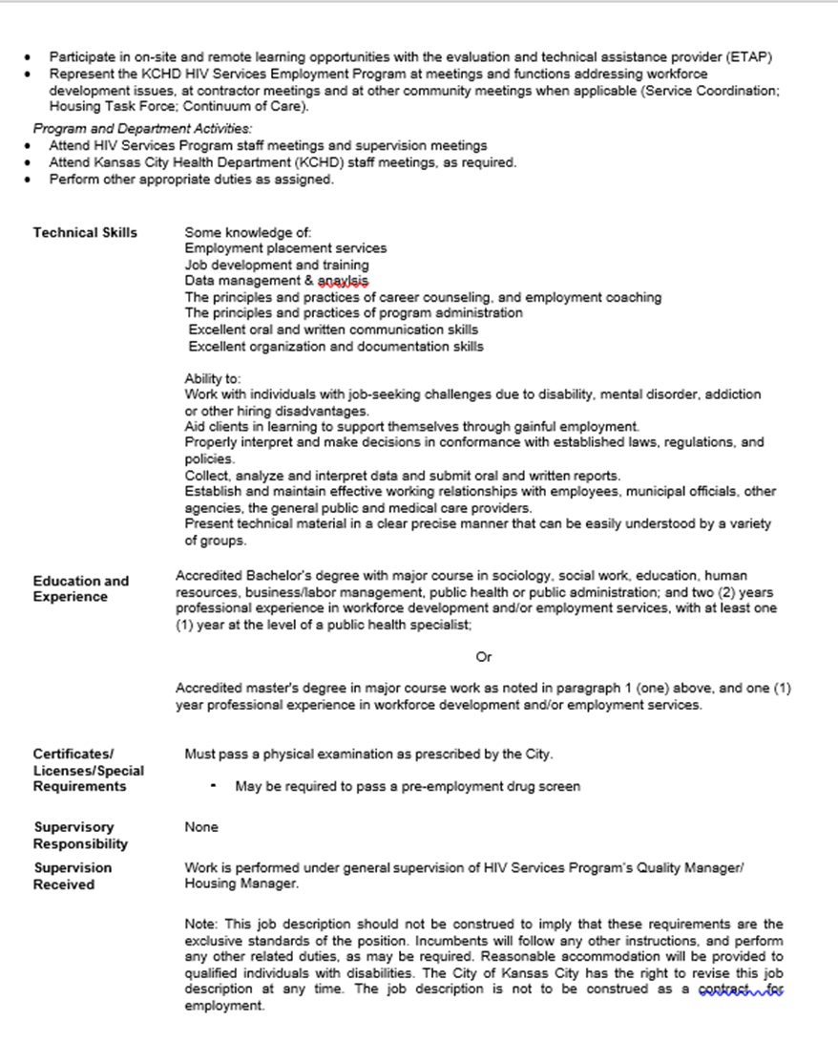

Job Description – KCHD Clinical Data Evaluator
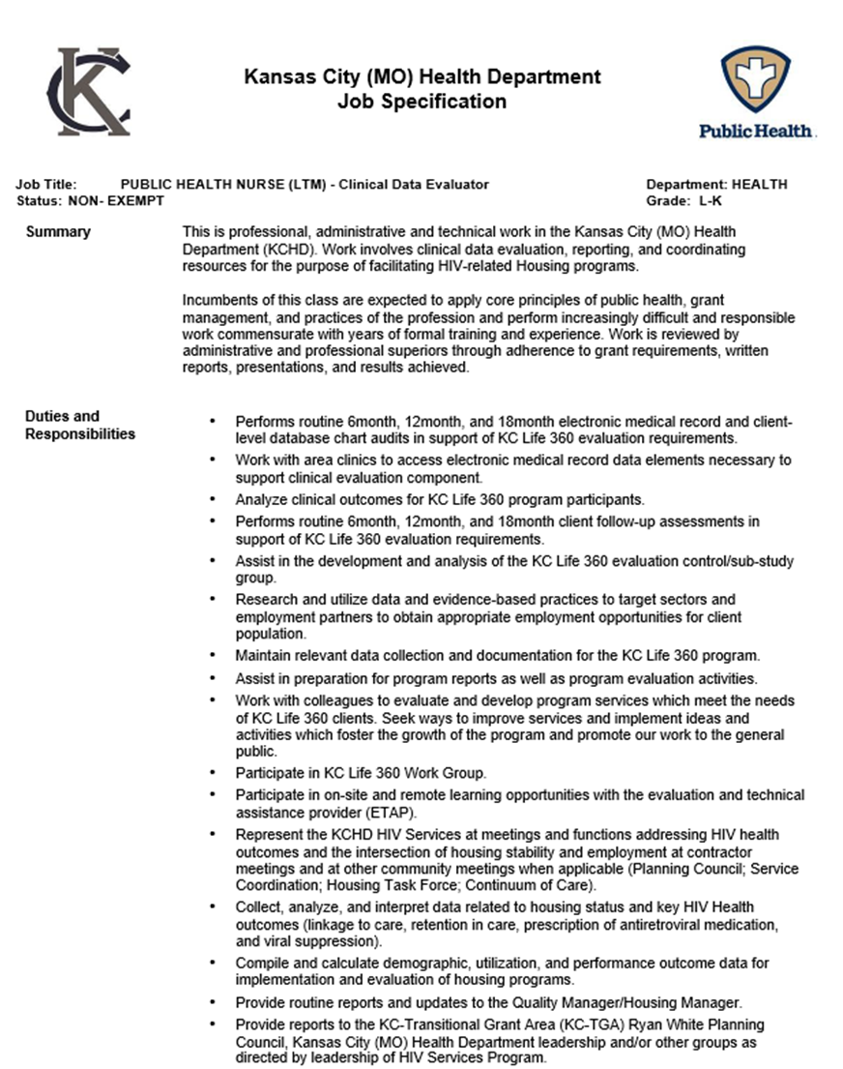

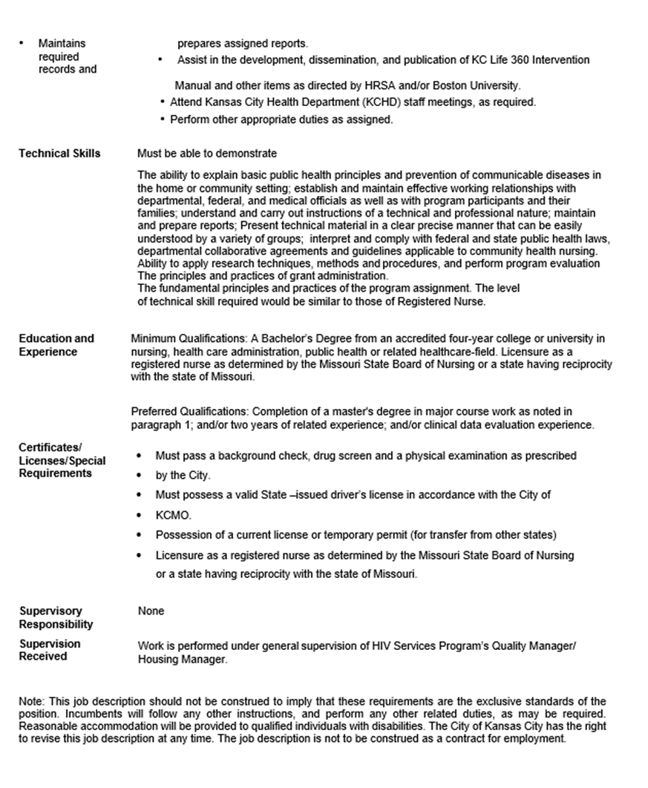

Job Description – KCHD Housing Support Specialist

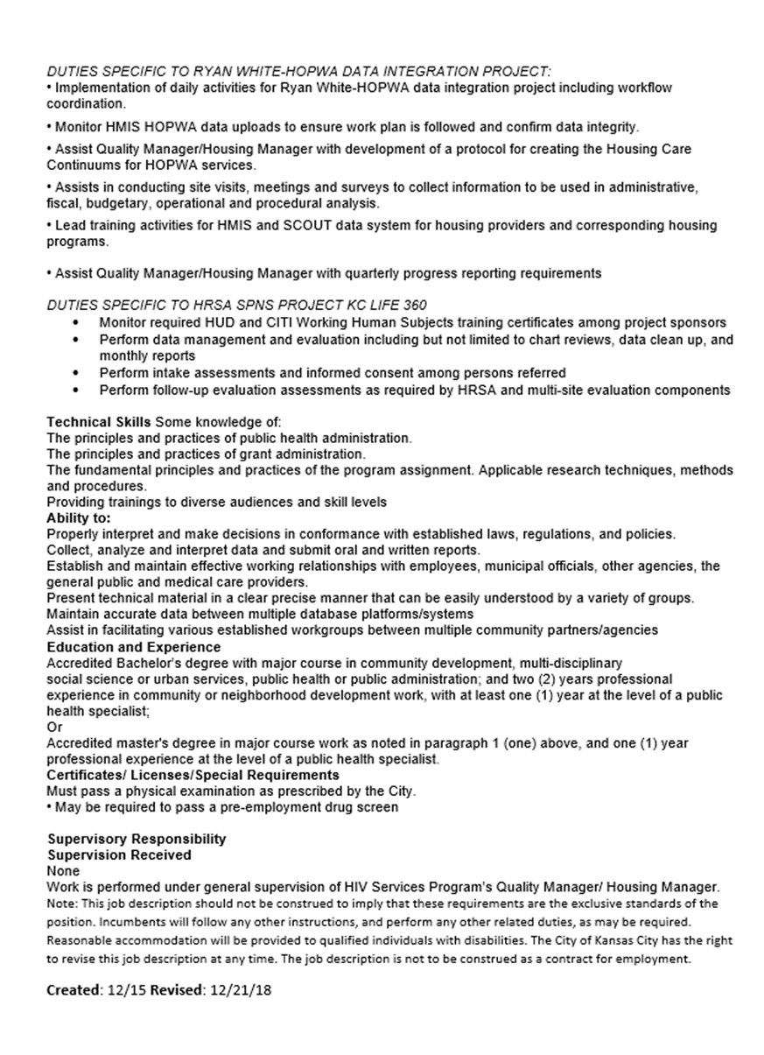

Job Description – KCHD Quality/Housing Manager
Job Title: ADMINISTRATIVE OFFICER – QUALITY/HOUSING MANAGER
Department: HEALTH Status: EXEMPT Grade: ME‐E

Summary:
This is specialized professional, administrative and technical work managing a comprehensive health program. Work involves responsibility for planning, administration and quality management in the HIV Services program, including federal grant programs, related public health social problems and pertinent operational responsibilities. This position is expected to exercise considerable initiative and broad independent judgment. Work accomplishments are reviewed and judged by the Manger of HIV Services through supervisory meetings, written reports, observation and results achieved.

Duties and Responsibilities:
DUTIES SPECIFIC TO RYAN WHITE GRANT AND OTHER HIV-RELATED PROGRAMS:
- Supervises HIV quality management activities including liaison with relevant stakeholders.
- Develop, coordinate, and evaluate all the quality management reporting from contracted providers.
- Devises and implements quality management and monitoring systems to ensure Ryan White services meet the national and professional quality standards; presents results and analyses of quality and demographic data for each services category funded by the Ryan White Part A, B and MAI funds.
- Organize Quality Management training for the professional staff of partner agencies.
- Provides Ryan White Planning Council with a quarterly quality analysis for each funded service category.
- Maintains HIV-related and housing related records and prepares reports as necessary.
- Develop the HIV Quality Management Plan for the Kansas City Transitional Grant Area (KC- TGA).
- Facilitate the KC-TGA HIV Quality Advisory Committee.
- Collaborate with HIV Quality Management Programs for Kansas and Missouri.
- Present to City Council regarding contract amendments and other program updates as delegated.
- Participates in quality improvement initiatives and activities at the local, state and federal level.
- Translation of practice guidelines into clinical indicators for performance measurement
- Development of indicators through structured group decision-making methods to measure the quality of supportive services
- Conduct on-site quality reviews/monitoring visits for contracted services providers
- Support the development of high-quality HIV care for people living with HIV disease (PLWH)
- Identify priority needs and client populations
- Demonstrate program value quantitatively by linking outputs (amounts of services provided) to outcomes (client-level and program-level results)
- Identify and justify critical program activities and resources required to meet needs
- Enable local, HIV service providers to perform better and function as a system providing improved access to and retention in care for HIV-positive individuals
- Recommending program changes needed to respond to the local HIV epidemic.
DUTIES SPECIFIC TO HOUSING GRANTS AND OTHER HOUSING PROJECTS:
- Provide oversight for coordination/evaluation of all housing grants for the HIV Services Pro- gram.
- Implements HIV-related housing projects with approval of Manager of HIV Services.
- Serves as KCHD representative on client hearings related to HIV housing grants.
- Provide routine reports and updates to the Manager of HIV Services.
- Provide housing reports to the KC-Transitional Grant Area (KC-TGA) Ryan White Planning Council, Kansas City (MO) Health Department leadership and/or other groups as directed by Manager of HIV Services.
- Complete required grant reports (including CAPER) for HIV housing services.
- Establish and maintain partnerships with local housing agencies and members of the local HUD Continuum of Care for the Kansas City region.
- Provide in learning opportunities related to housing services for Persons Living with HIV/AIDS (PLWHA).
- Performs related duties as assigned.

Catholic Charities Job Descriptions

Position Title: Workforce Development Program Manager Effective Date: 12/20/2016
Status: Full‐time, exempt Program: Workforce Development
Reports to: Director of Workforce Development
I understand that as an employee of Catholic Charities I am expected to perform in a manner consistent with the stated characteristics as outlined on the Performance Based Evaluation form and the following mission characteristics:
- Strictly follows the Catholic Social Teachings in all aspects of the duties of this position
- Collaborative and participatory leadership styles with commitment to excellence in service provision
- Works collaboratively to achieve goals and resolves conflict to achieve the greater good
- Respect for the diversity of talents and gifts of others and belief in cultivating those to promote personal and professional development
Cares about quality of life and well-being of others, thus demonstrating compassion and commitment for helping others improve their own lives
Essential Duties
Stewardship
- Maintain program oversight and ensure compliance of grants and contracts
- Oversee the acquisition, spending and monitoring of program funds, as assigned
- Oversee client/participant assessments and intakes which include information on program guide- lines and expectations as well as required documentation for admission to a Workforce Development program, as indicated
- Follow all agency and program policies and procedures including confidentiality
- Provide financial assistance in accordance with program policy and procedures; assure the accurate records of financial and other assistance provided to participants in the participant/client file, in ETO, and in alternate data systems (if indicated). Maintain information and statistics per program guidelines; complete reports as requested and assigned by supervisor
- Provide grant writing and contract/grant reports assuring that grant and reporting requirements are met
Teamwork and Collaboration
- Provide outreach services as needed and requested by supervisors
- Work with the Director and finance department in creating and monitoring budgets
- Work closely with marketing program to publicize programs
- Attend agency and community meetings as requested. Maintain working relationships with
community agencies, including probation and parole staff, to provide comprehensive services to clients and to stay abreast of current trends and available resources including internal and external conferences/workshops as required, and approved by supervisor
- Work toward developing a strong Workforce Development team which includes staff and volunteers, in order to serve clients well, appropriately, and as a team
- In all community activities, represent the agency’s mission, purpose and philosophy to the community
- Provide guidance and support to community volunteers working within the program
- Perform other activities as needed and requested by supervisor with the goal of attaining and maintaining smooth program operations.
Commitment to Customers
- Provide client advocacy services as needed
- Treat all internal and external customers with respect and exhibit positive behavior in dealing with clients, participants, co-workers, supervisors, volunteers and interns, partners, collaborators, and the general public
- Work in the Welcome Center as requested
- Perform other activities as needed and requested by supervisor with the goal of providing excellent quality of services for the clients/participants, the agency, and community.
Leadership and Management
- Implement, manage and expand programs, assuring high quality services
- Supervise and monitor program outcomes and tracking of related data
- Engage and supervise volunteers as needed in each program, or delegate supervision of volunteers
- Work to assure the success of the Workforce Development Strategic Plan

_____________________________________________________________________
Position Title: Career Development Specialist Effective Date: Status: Full‐time non‐exempt Program: Workforce Development
Reports to: Program Manager
I understand that as an employee of Catholic Charities I am expected to perform in a manner consistent with the stated characteristics as outlined on the Performance Based Evaluation form and the following mission characteristics:
- Strictly follows the Catholic Social Teachings in all aspects of the duties of this position
- Collaborative and participatory leadership styles with commitment to excellence in service provision
- Works collaboratively to achieve goals and resolves conflict to achieve the greater good
- Respect for the diversity of talents and gifts of others and belief in cultivating those to promote personal and professional development
- Cares about quality of life and well-being of others, thus demonstrating compassion and commitment for helping others improve their own lives

Position Objective
Provide employment assistance to individuals and families to achieve economic stability and security.

Essential Duties
- Stewardship
  - Services will be provided primarily to a targeted population as directed by funder.
  - Provide employment preparation services in workshops as well as individually, including resume building, interviewing skills, interview etiquette, etc.
  - Assist with job retention and career pathway activities through providing information both to individuals and in a group setting on topics such as conflict-resolution, decision-making and problem- solving
  - Assist with identifying career strengths and potential on paper and electronically, per program policies and as directed by supervisor; maintain client records as indicated
- Provide financial assistance in accordance with program policy and procedures; maintain accurate records of financial and other assistance provided to participants in the participant/client file, and in other appropriate data bases as indicated
- Follow all policies and procedures regarding the agency including confidentiality
- Maintain information and statistics per program guidelines; complete reports as requested and as- signed by supervisor
B. Teamwork and Collaboration
- Collaborate with partners in serving a targeted population regularly, via phone, e-mail and personal meetings, with the goal of service coordination.
- Provide outreach services to potential employers and employment agencies as needed and requested by supervisor
- Attend agency and community meetings as requested; maintain working relationships with community agencies, including probation and parole staff, to provide comprehensive services to clients and to stay abreast of current trends and available resources.
- Attend in-service training including internal and external conferences/workshops as required, re- quested and approved by supervisor
- In all community activities, represent the agency’s mission, purpose, and philosophy to the community
- Provide guidance and support to community volunteers working within the program
- Perform other activities as needed and requested by supervisor with the goal of attaining and maintaining efficient program operations
- Commitment to Customers
  - Provide client advocacy services as needed
  - Provide information and referral services to internal and external resources
  - Treat all internal and external customers with respect and exhibit positive behavior in dealing with clients, participants, co-workers, supervisors, volunteers and interns, partners, collaborators, and the general public
  - Work together with other staff to be a change agent so that the client/participant will be a productive, successful citizen
  - Perform other activities as needed and requested by supervisor with the goal of providing an excellent quality of services for the clients/participants, the agency, and community

reStart Job Descriptions
Title: Clinical Program Manager
Reports to: Director of Programs and Services

Position Summary
Successfully advance the mission of reStart through the development, implementation and management of clinical programs and services.

Primary Accountabilities
- Conduct in-depth mental health assessments or screenings, evaluate results and mutually develop plans for recovery.
- Provide weekly individual, family, and/or group therapeutic counseling sessions, or as needed.
- Develop and revise mental health goal plans as needed.
- Provide continuity of mental health services, coordinate, and facilitate referral services with other
community mental health agencies, as needed.
- Oversee program and funder compliance for all assigned grants, contracts and programs.
- Develop and sustain partnerships with other community healthcare providers.
- Maintain accurate and up-to-date files and charts (charting each service provided within the required time period).
- Keep accurate client records and enter data into the MAAC Link system in a timely basis.
- Prepare statistical and outcome reports for funding sources, the board of directors as required.
- Provide crisis intervention services around mental health issues with program clients, including clients in the Overnight Emergency Shelter program.
- Provide clinical and administrative oversight for healthcare for homeless veterans, transitional living and federal probation programs.
- Lead training case presentation meetings, clinical staffing, staff meetings
- Foster a workplace that results in the development of a high performing team of professionals and staff.
- Recruit, develop and inspire a highly effective team. Insure that all staff are properly coached and directed, and that clearly defined measurements of performance and rewards are utilized to enhance individual and organizational effectiveness.
- Other duties as assigned.
Essential Functions
- Demonstrate a high level of problem solving skill. Demonstrate the ability make critical case management decisions supported by substantial financial analysis, clinical knowledge, and critical data based decision making.
- Demonstrate interpersonal savvy and influence skills in all dealings with the media, government entities, financial community, regulatory entities and related concerns.
- Ability to travel throughout the city to monitor operational performance and activity, and to establish relationships with key resources and affiliates.
- Ability to establish and maintain clearly defined measurements of services, to include statistics, financial data, benchmarking, billing information and service evaluations.

Requirements
- Demonstrated passion for the mission of reStart.
- Current clinical licensure in the state of Missouri.
- Proven managerial skill with ability to recruit, hire, develop, coach and assess a high-performing team of professionals.
- Excellent communication skills.

Typical Outcomes Measurements
- Fiscal management
  - financial budgets and projections well planned and accurate
  - targeted financial related measures established in advance
  - expenses within budget
- Clinical measures
  - Trends in number of clients served.
  - Cost per unit of service provided…measured within budgets, benchmarks, industry standard and expected outcomes.
  - Effectiveness of client services measured by predetermined standards.
  - Productivity of cases handled per week versus industry standards.
  - Client satisfaction surveys.
  - Maintain applicable accreditation, licensing etc.
  - Survey/ audit results from state and local agencies, accreditation organizations, etc.
  - Meet or exceed expectations on all financial and control audits
  - Favorable feedback/ renewal of community grants and funding for specific initiatives

Title: Case Manager/Referral Specialist
Reports to: Director of Programs and Services
Description: This position is responsible comprehensive strength-based case management services to adults in the Adult Emergency Shelter with the primary goal of achieving permanent housing.

Responsibilities Include:
- Complete housing plan with new clients within 7 days of intake.
- Input data into MAAC Link and SCOUT database on a timely basis.
- Complete all required documentation and case notes and maintain all reStart case files.
- Provide assistance for clients in: budgeting, employment search, locating permanent housing, man- aging medical issues, and addressing transportation and other needs.
- Make and facilitate appropriate client referrals to community service providers for medication management, day treatment, inpatient care, domestic violence support, and continued access to integrated services. Track and assist client to ensure engagement and follow through on referrals.
- Maintain current knowledge of and good working relationships with other service providers with whom reStart collaborates. Attend inter- agency meetings as required.
- Meet grant deliverables, outcomes and expectations, including data collection and reporting requirements, as needed.
- Conduct weekly floor meetings, room inspections, make weekly chore assignments.
- Other duties as assigned.

Qualifications
- Bachelor's degree in social work or related field required. (Master’s preferred). 3-5 years’ experience in social services field preferred.
- Ability to write clear, accurate case notes and complete other required case documentation thoroughly and accurately.
- Able to handle crisis situations with a minimum of supervision.
- Must have driver’s license and insurance.
- Work schedule includes days, evenings and weekend hours.
- Must pass criminal records check.
- Proficiency with PC-based word processing and database documentation required.

